***Lab 8-LINQ with MVC***

*Create a new MVC Application:*

*File > New > Project > Project Name: LINQwithASP.NET > Click OK Button > Select MVC and click OK button.*

*Project will be create.*

*Add Model:*

*Right click on Model folder > Add > Class > Name = Product class.*

*Add the following code:*

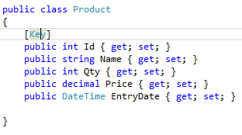

*Create Folder > Name = Context > Right click on the context folder > Add > Class > Name = ProductContext.*

*Add the following code:*

**

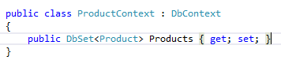

*Make modifications in the Web.config*

*Change the connection string name as “ProductContext” > Change Initial Catalog to “Inventory”*

**

*Create a Controller:*

*Right click on Controller folder > Add > Controller*

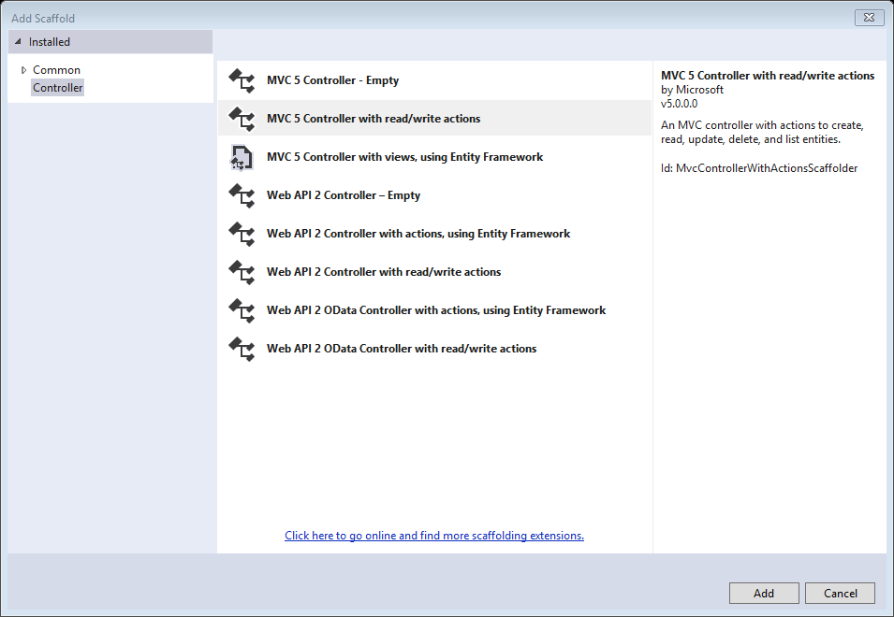

*MVC5 Controller with read/write actions > click Ok*

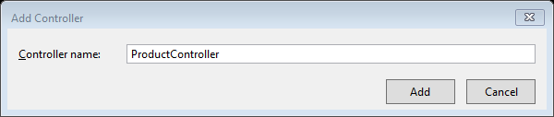

*Controller Name = ProductController.*

*Add the following code in the Controller:*

**

*In the Index action:*

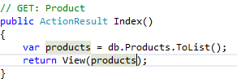

*Build the project*

*Right click on Index action > Add View*

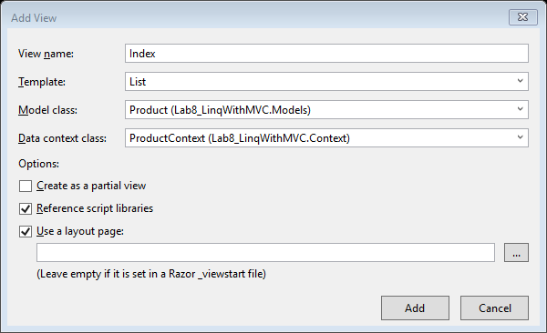

*Template = List > Model class = Product > Data context class = ProductContext > Add*

*Right click on Create action > Add View*

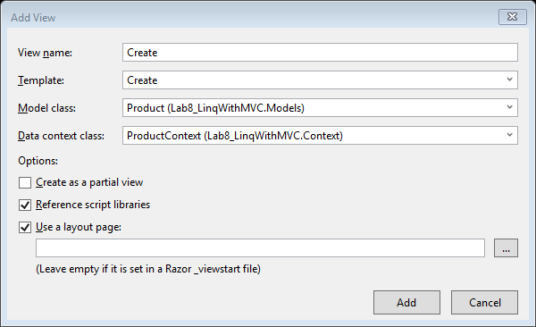

*Template = Create > Model class = Product > Data context class = ProductContext > Add*

*Add the following code in ProductController*

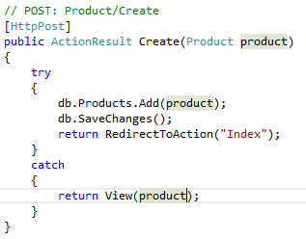

*After execution:*

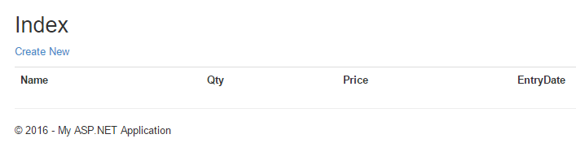

*When u click on Create New form will open:*

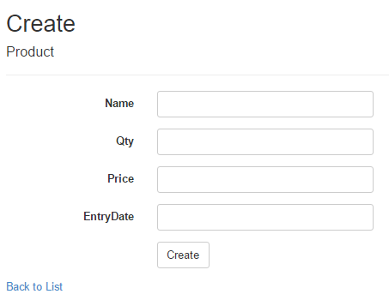

*On clicking on EntryDate we want to get the date picker.*

*Right-click on your Project in Solution Explorer > Select the "Manage NuGet packages" option.*

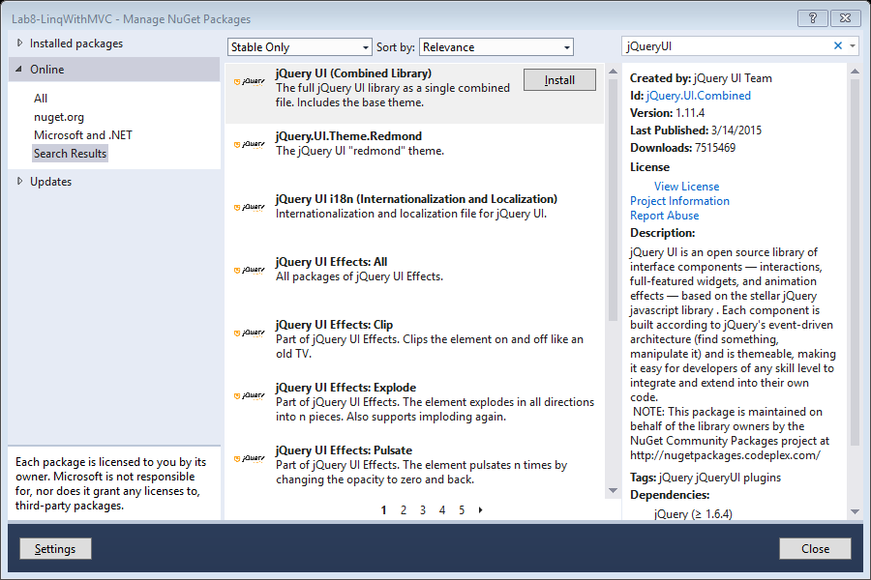

*Search for "jQueryUI" > Click "Install" option for the jQuery UI (Combined Library) package that appears within the results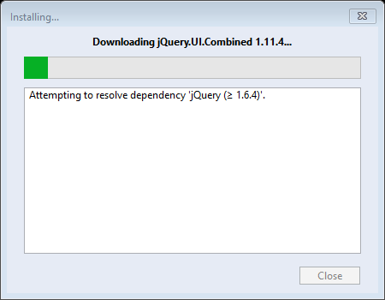*

*The software will get installed > Click on close*

*Now we will implement Bundling concept. Add following code in BundleConfig.cs*

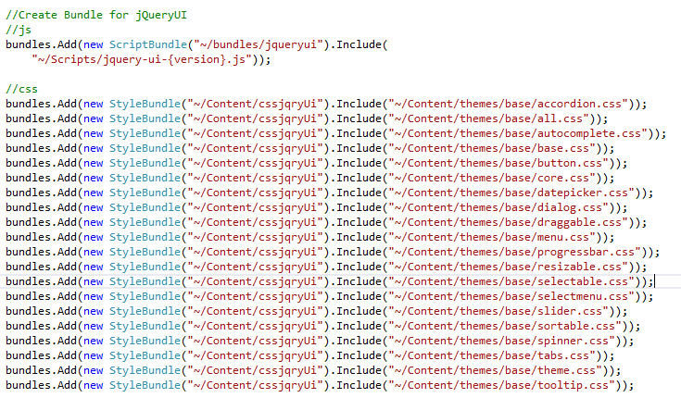

*Goto Create.cshtml and add the following code in @section Scripts block:*

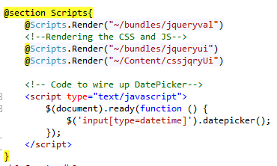

*Now add the following code in Product.cs*

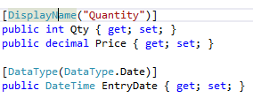

*Now when you execute the code, following will be the output:*

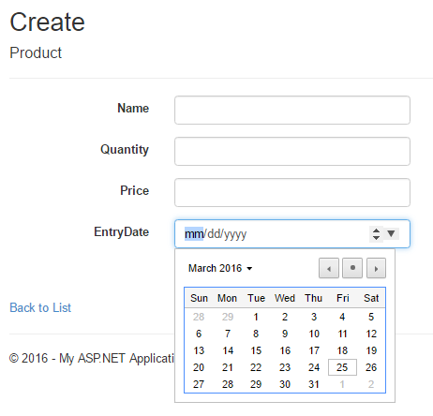

*Now add few products into the database using the GUI designed:*

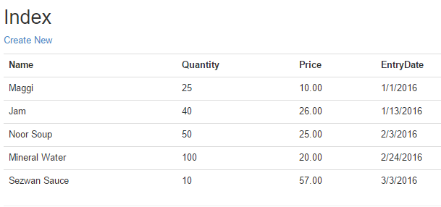

*Working with LINQ. For that we shall add 3 links in the Index.cshtml*

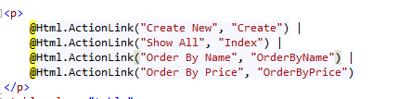

*In ProductController create all the OrderByName action method:*

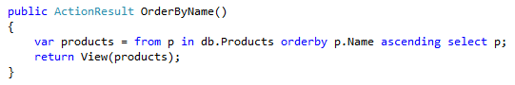

*Right click and add List view. And copy paste the other menu*



*In ProductController create all the OrderByPrice action method:*

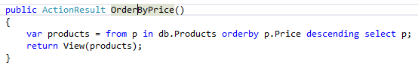

*Right click and add List view. And copy paste the other menu*



*The output will be as follows:*

